**SEQUENCE DIAGRAM**

**(AIR TICKET RESERVATION SYSTEM)**

1. **LOGIN AND SIGNUP SEQUENCE DIAGRAM**

**BASIC FLOW :**

* 1. Actor Logs into the system

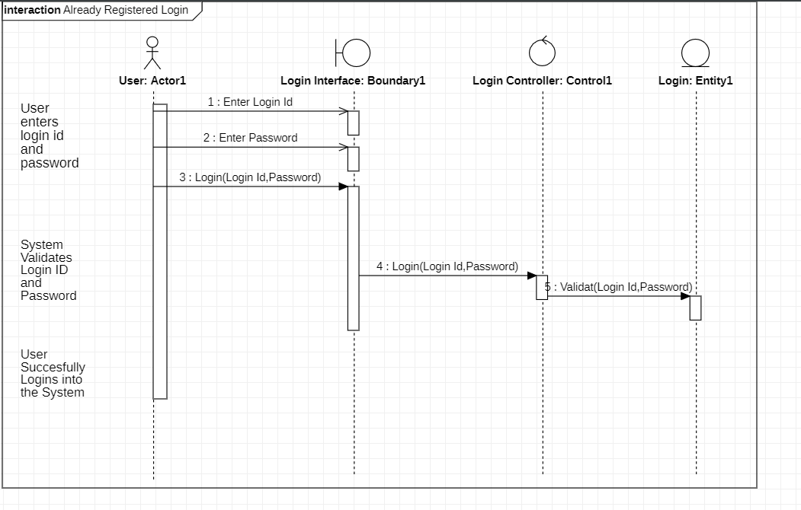

* 1. Actor tries to sign up into the system

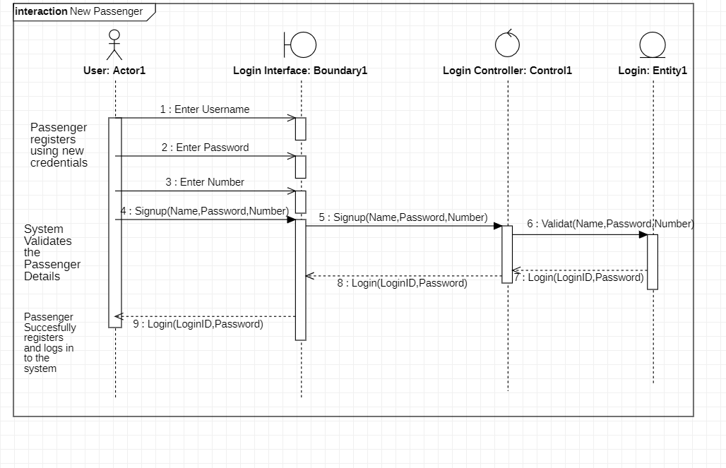

**ALTERNATE FLOW :**

* 1. Invalid Details

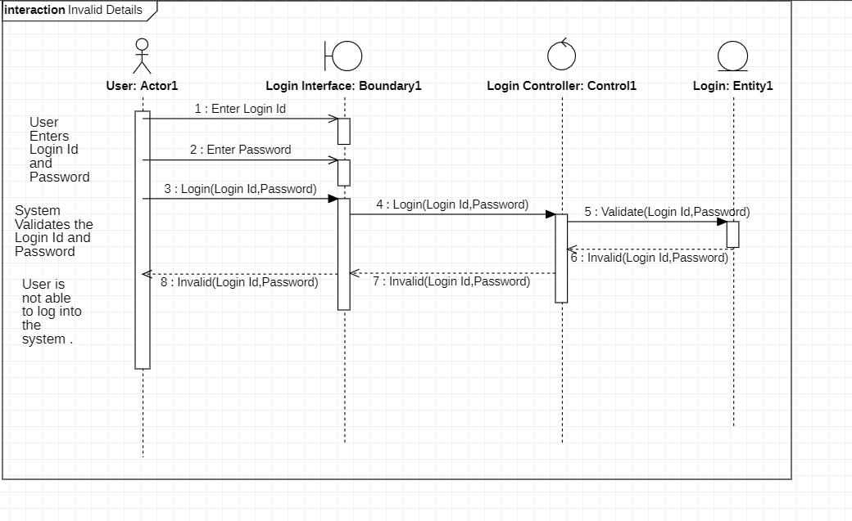

* 1. User Already Exist

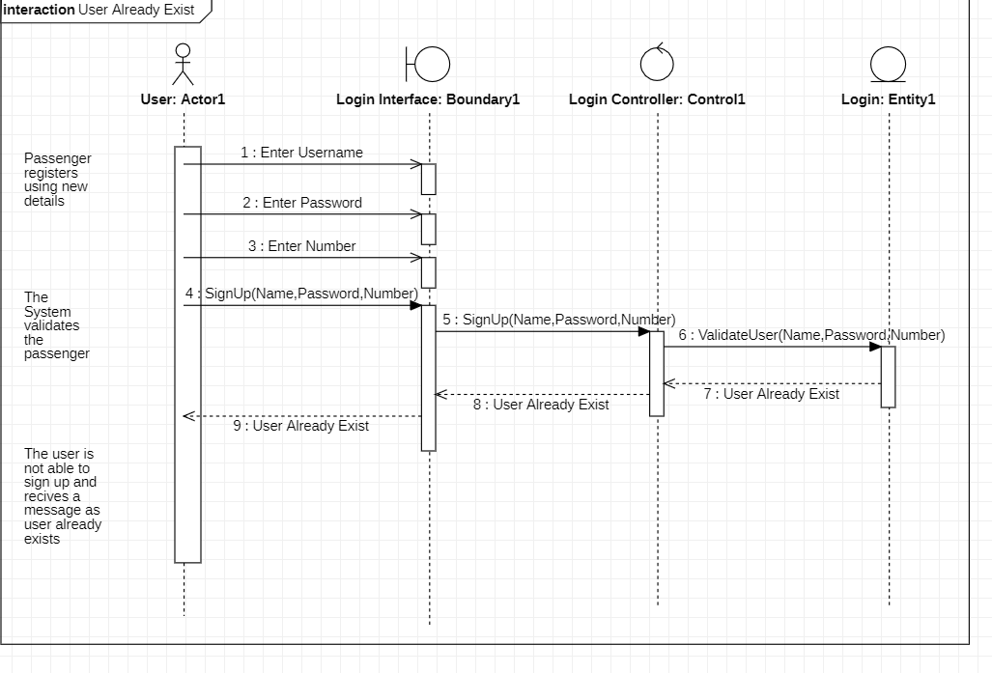

1. **BOOK TICKETS SEQUENCE DIAGRAM**

**BASIC FLOW**

2.1 Enter

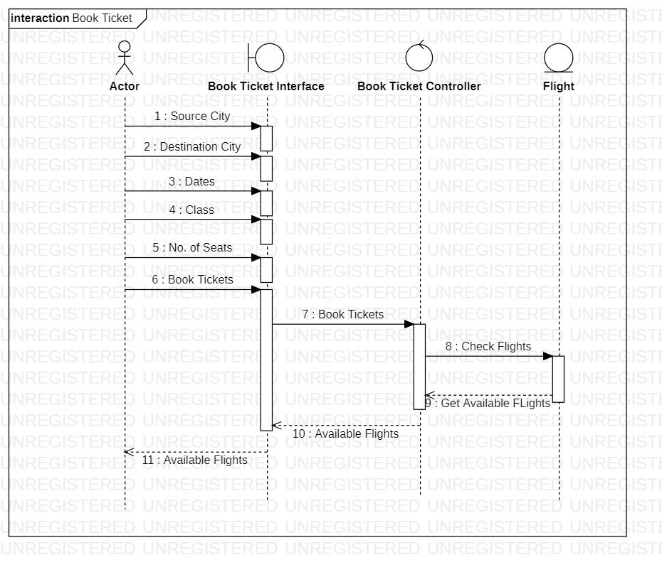

**ALTERNATE FLOW**

2.2 Invalid Details

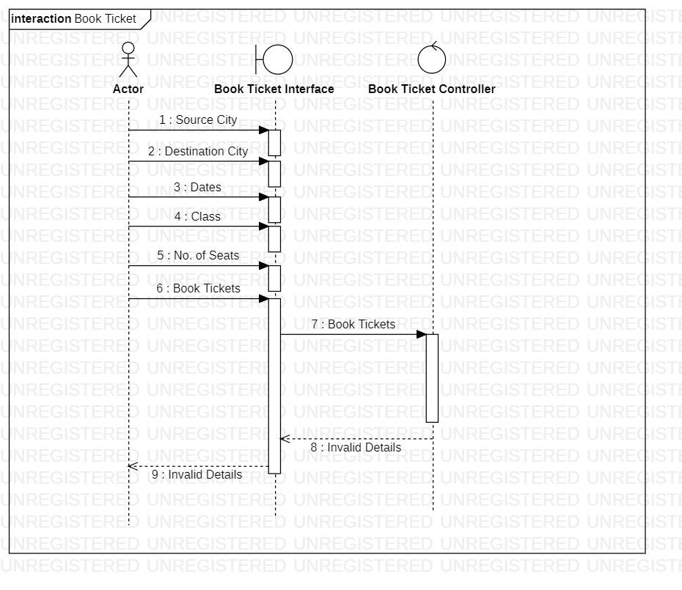

2.3 No flights available for selected Details

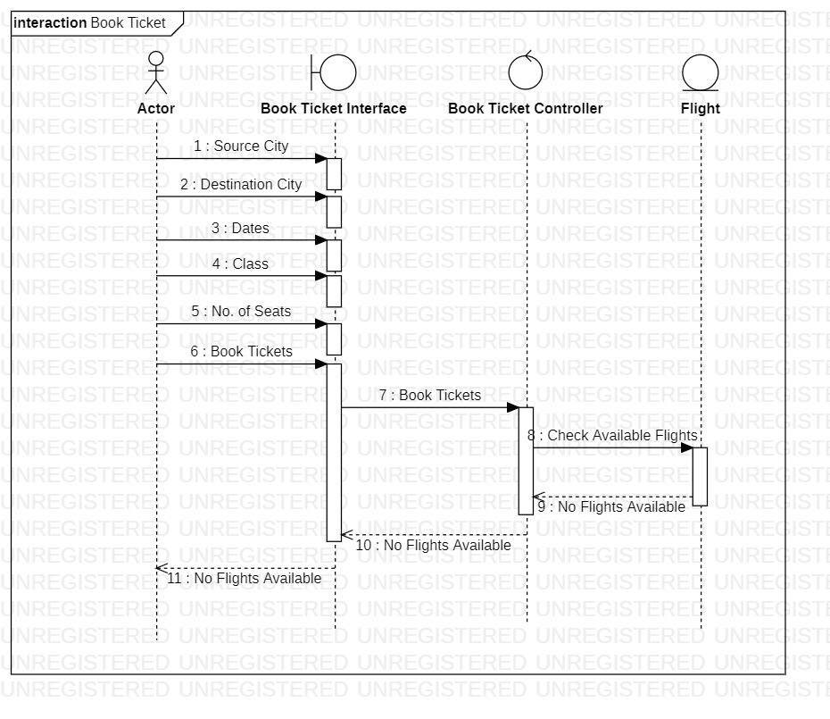

1. **VIEW TICKETS SEQUENCE DIAGRAM**

**BASIC FLOW**

3.1 Enter Details and view flights

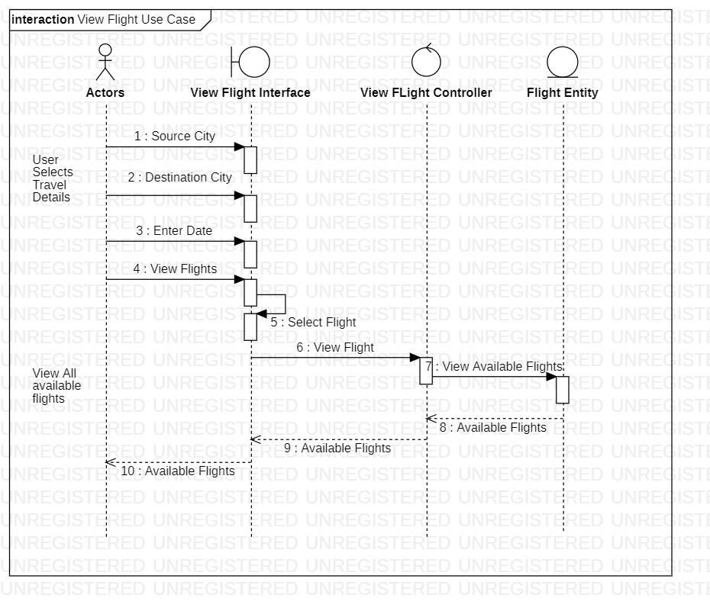

**ALTERNATE FLOW**

3.2 Source / Destination City is empty

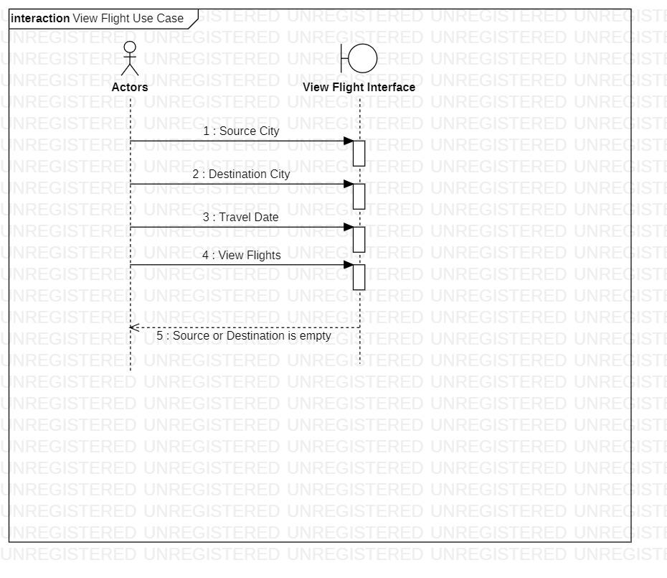

3.3 Travel Date is empty

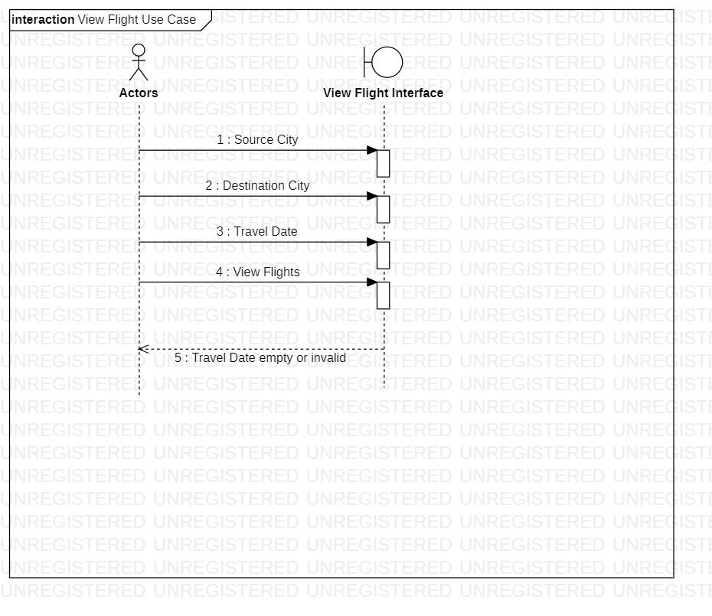

1. **MAKE PAYMENT SEQUENCE DIAGRAM**

**BASIC FLOW**

4.1 Add Payment details and make payment

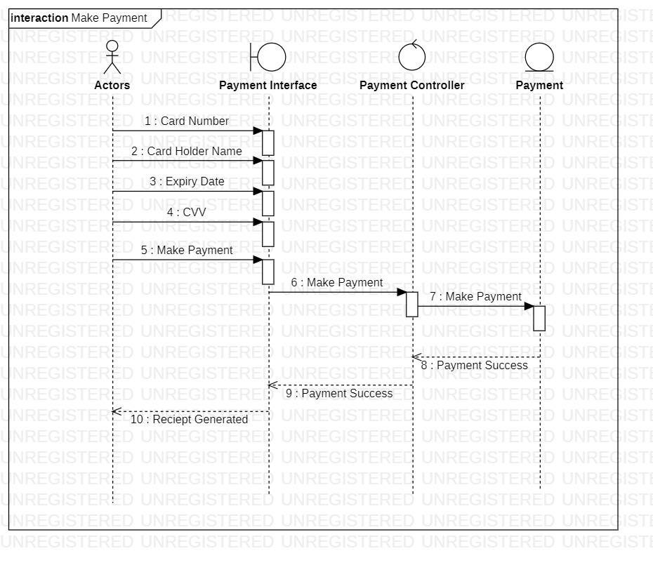

**ALTERNATE FLOW**

4.2 Invalid Payment Details

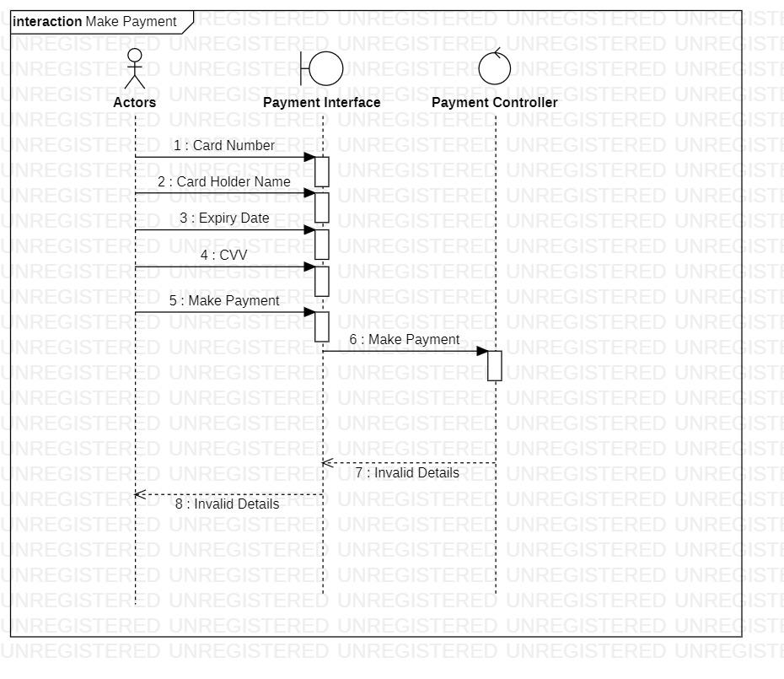

4.3 Time Exceeded – Transaction cancelled

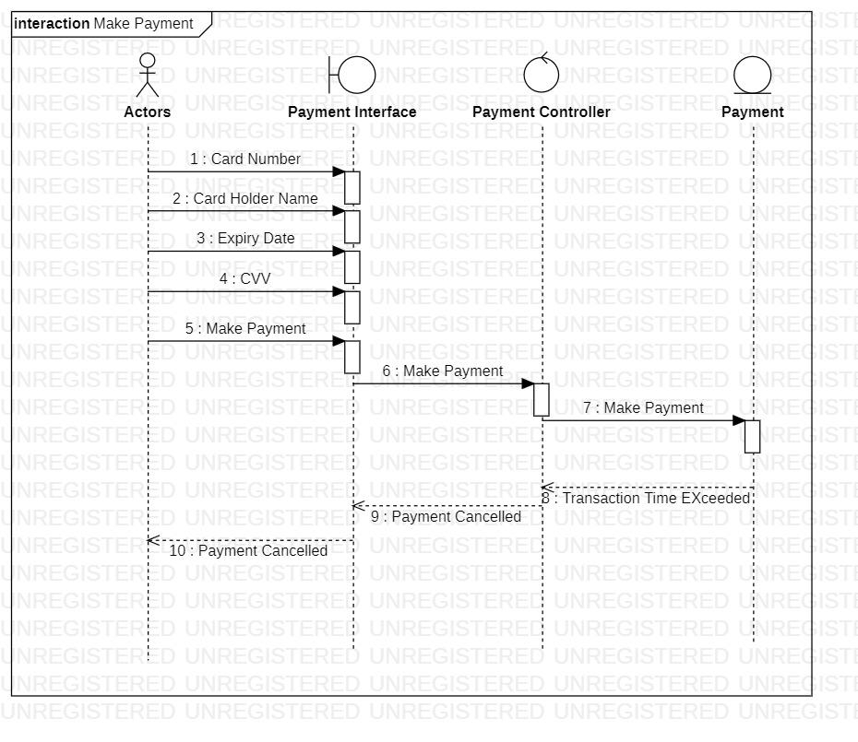

1. **CANCEL TICKETS SEQUENCE DIAGRAM**

**BASIC FLOW**

5.1 Cancel booked tickets

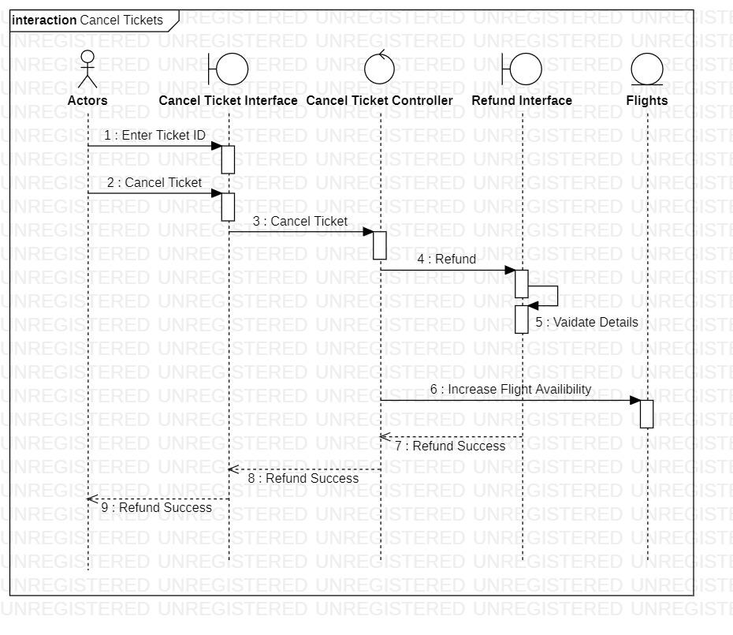

**ALTERNATE FLOW**

5.2 Invalid Details

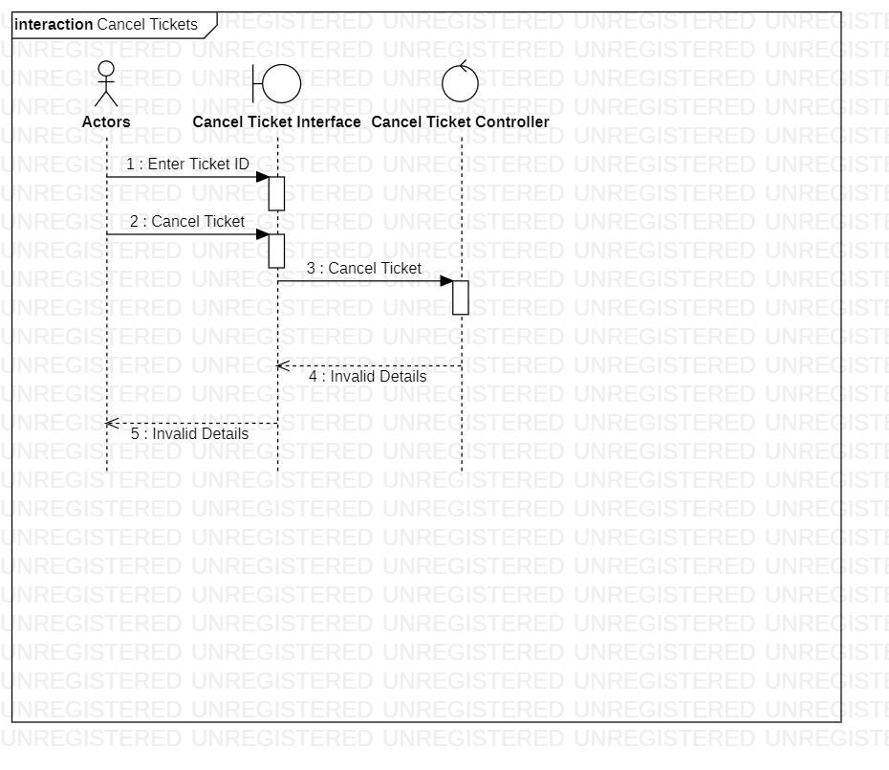

1. **REFUND SEQUENCE DIAGRAM**

**BASIC FLOW**

6.1 Refund paid amount for flight

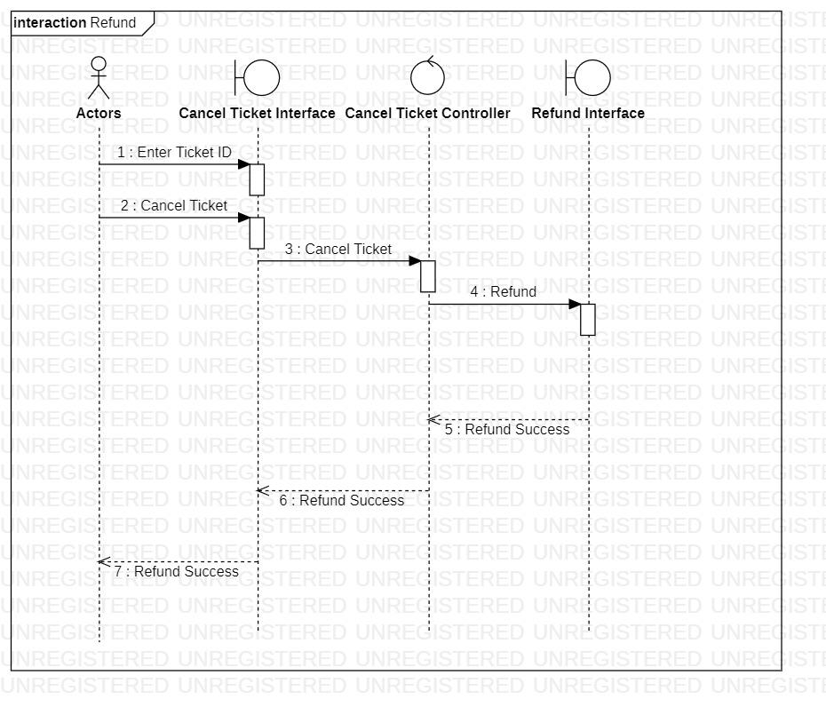

**ALTERNATE FLOW**

6.2 Invalid details of payment

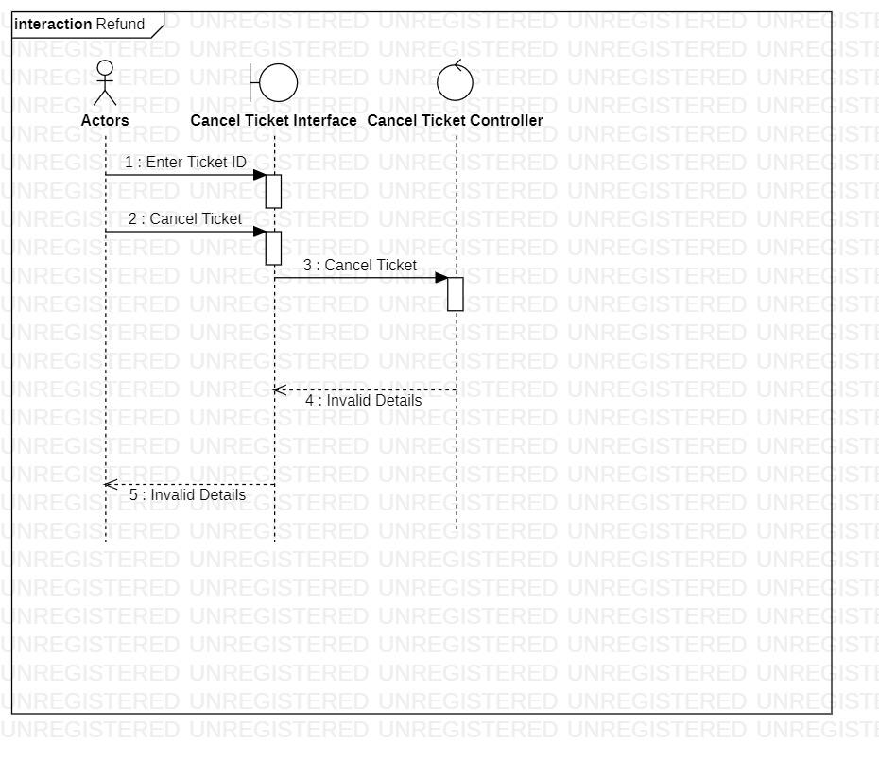

7. **ADD LUGGAGE SEQUENCE DIAGRAM**

Basic Flow

7.1 Add Luggage

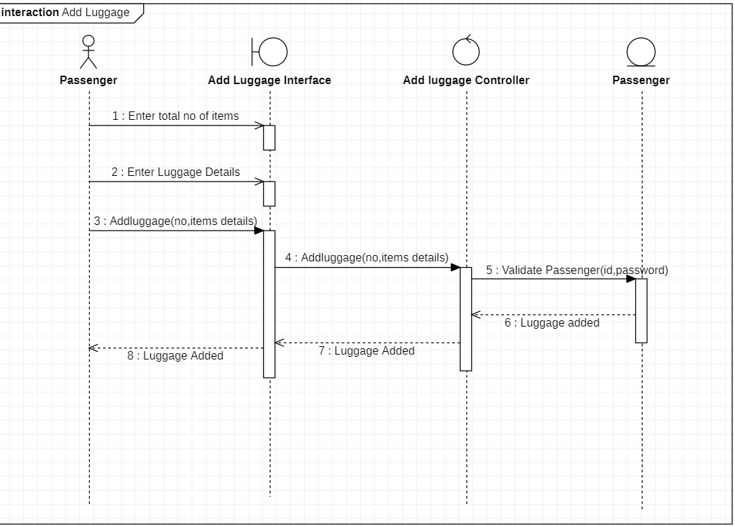

Alternate Flow

7.2 Invalid Details

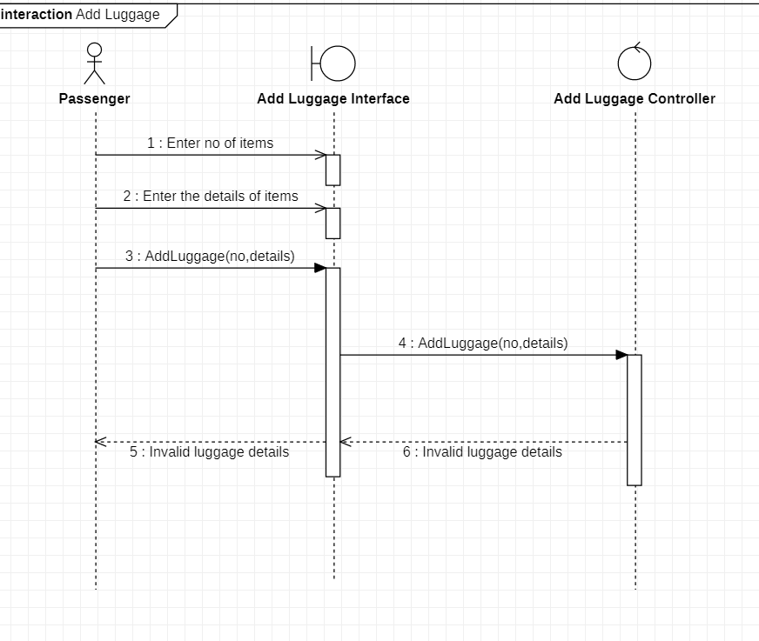

7.3 User Exits

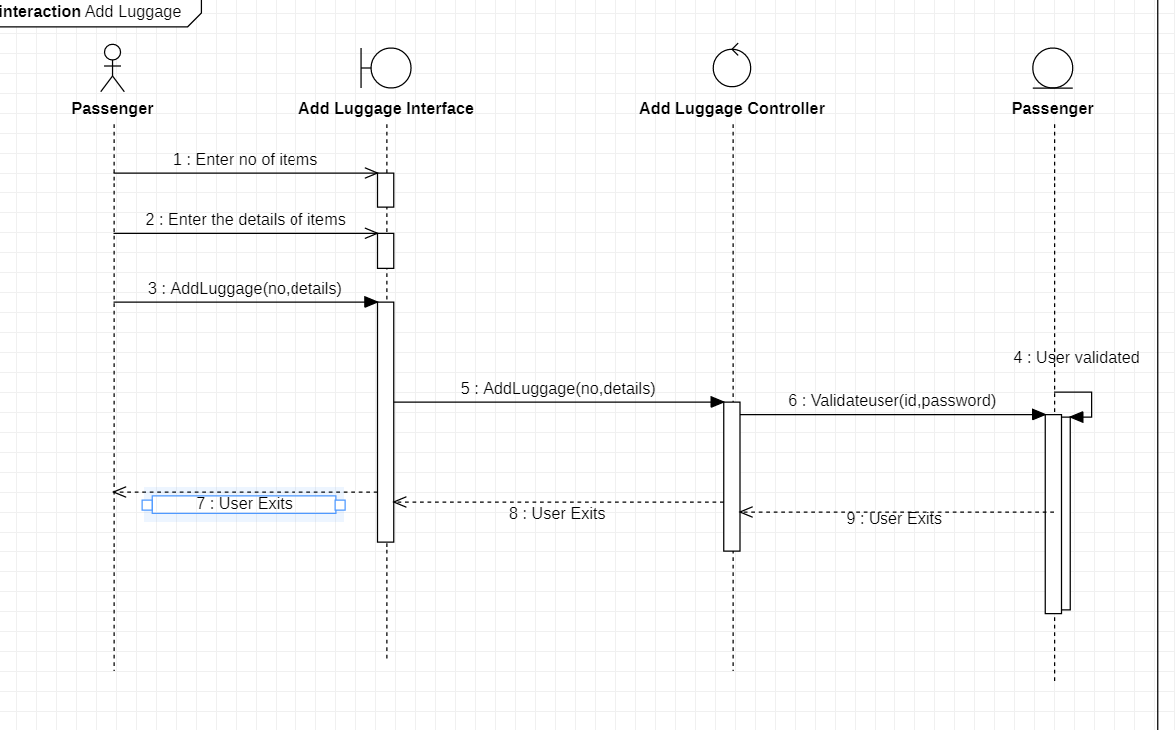

8. **ADD PASSPORT**

Basic Flow

8.1 Passenger adds passport details

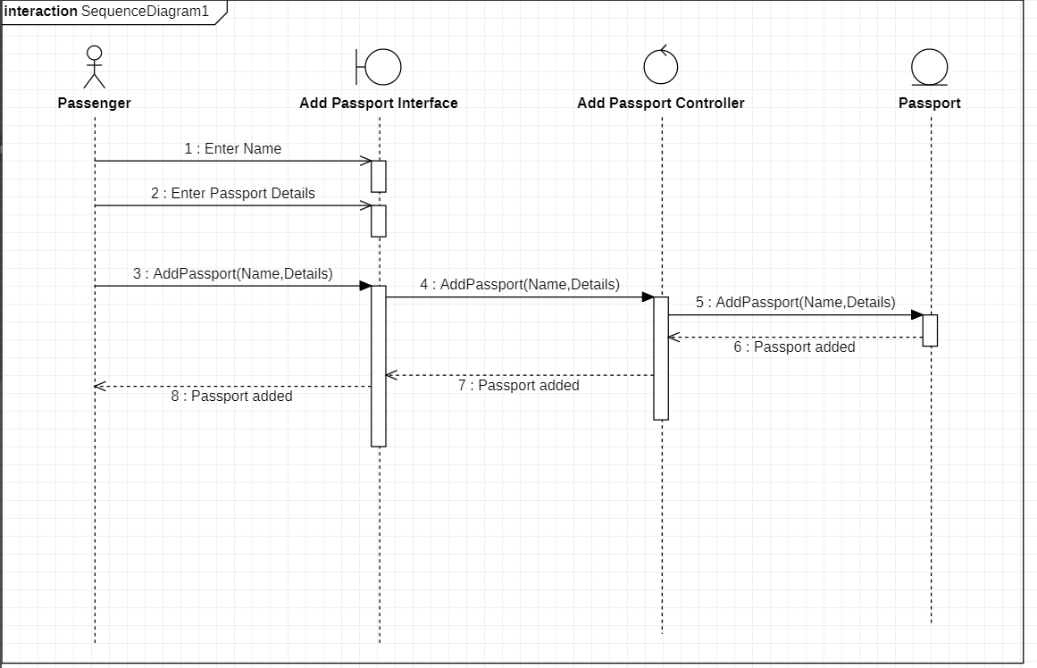

Alternate FLow

8.2 Invalid Passport Details

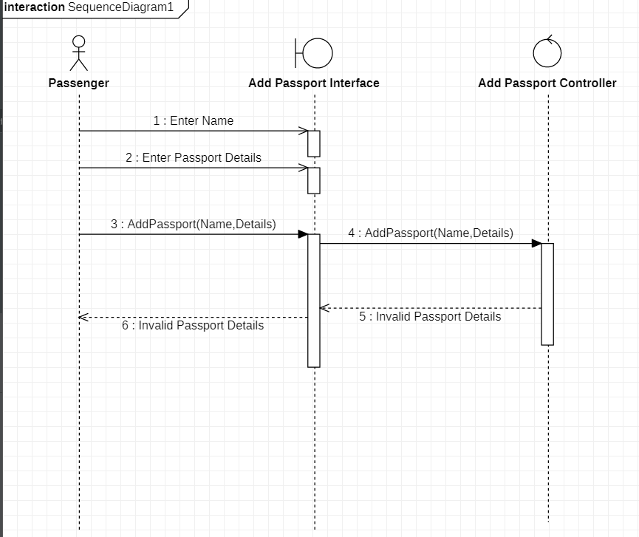

9 **MAINTAIN PASSENGER DETAILS**

Basic Flow

9.1 Add a Passenger

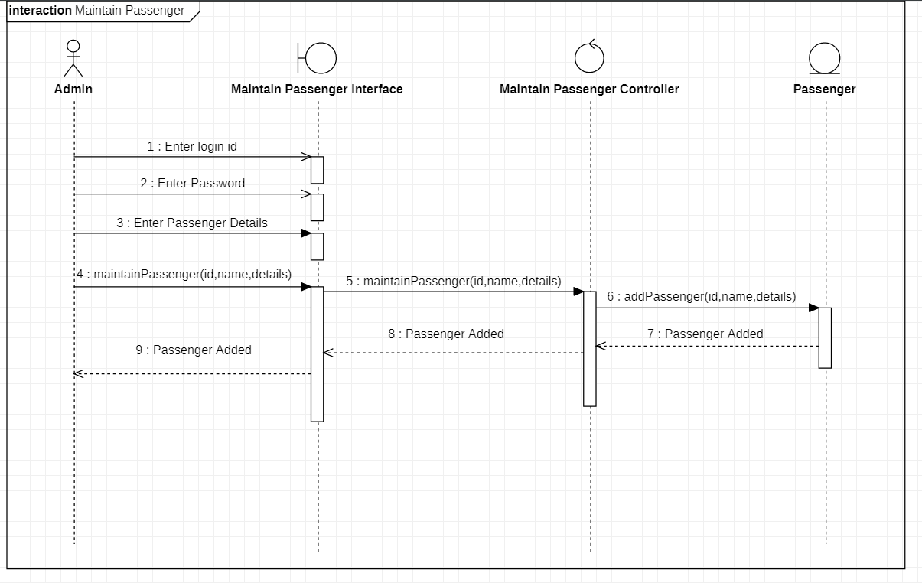

9.2 Update a Passenger

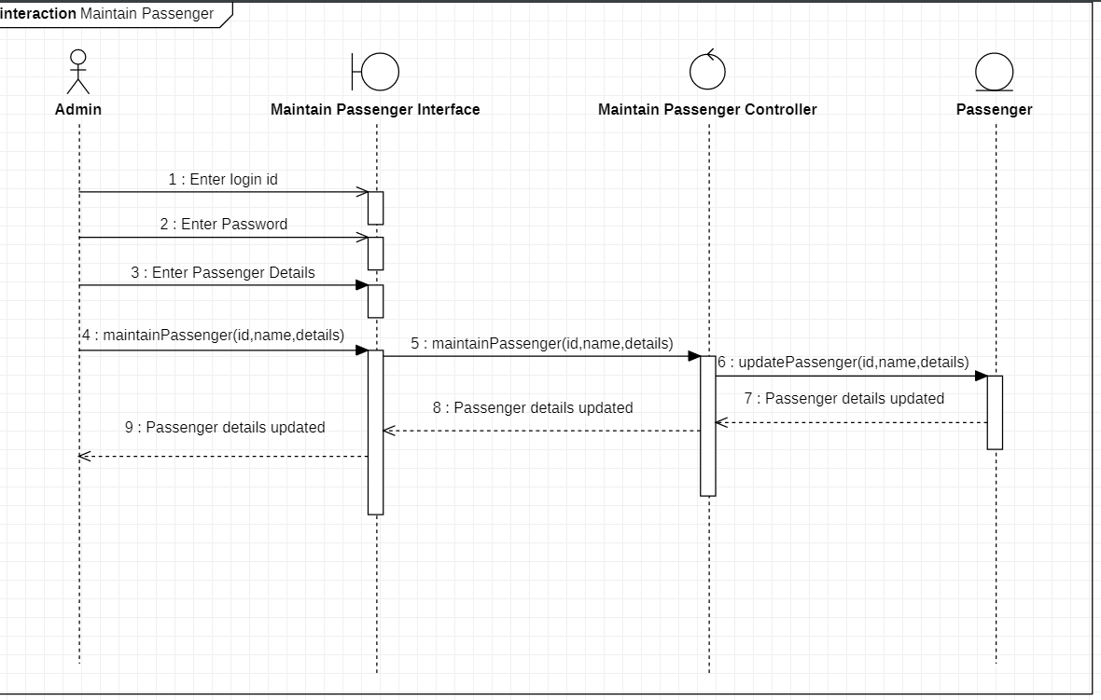

9.3 Delete a Passenger

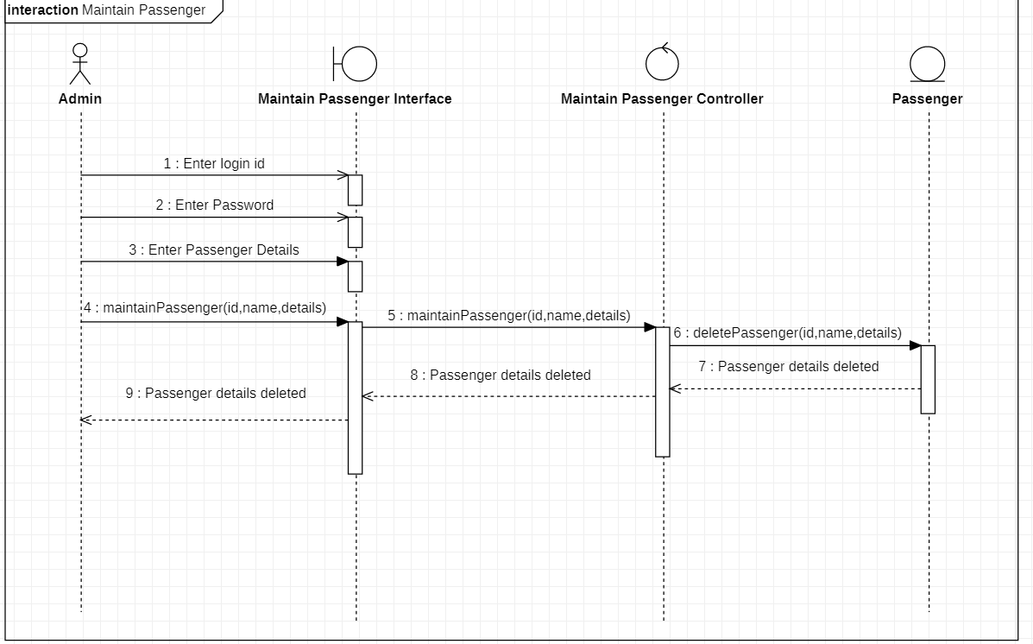

Alternate Flow

9.4 Invalid Details

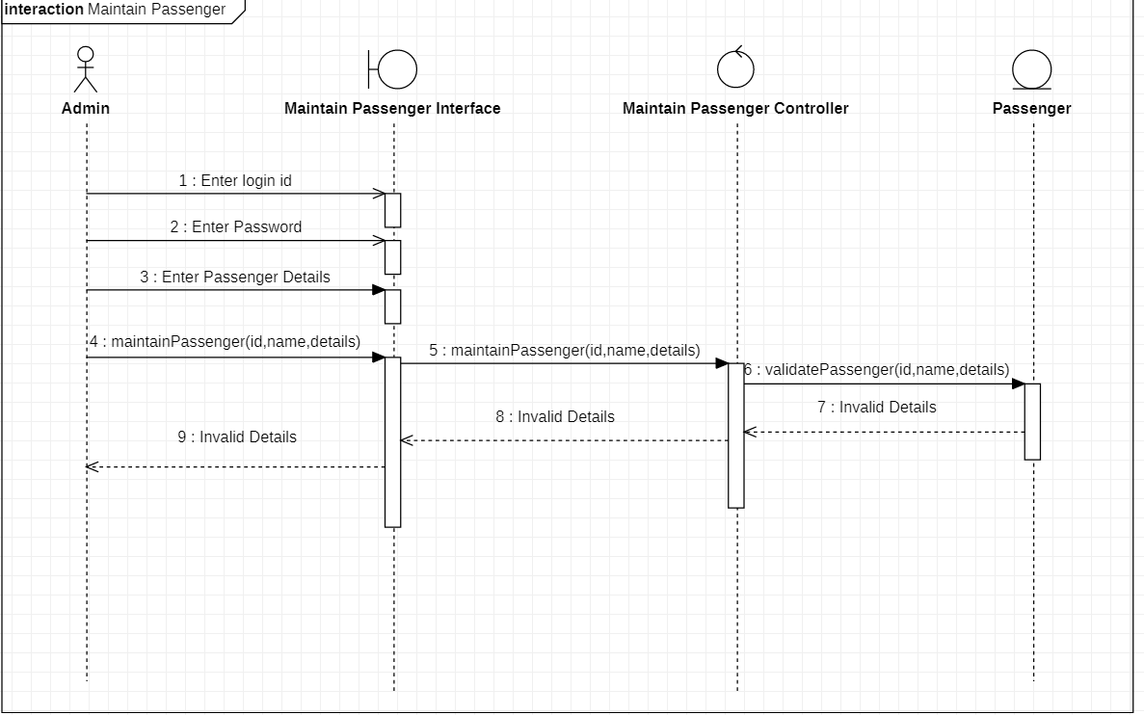

9.5 Passenger Already Exist- while adding passenger if the passenger already exist

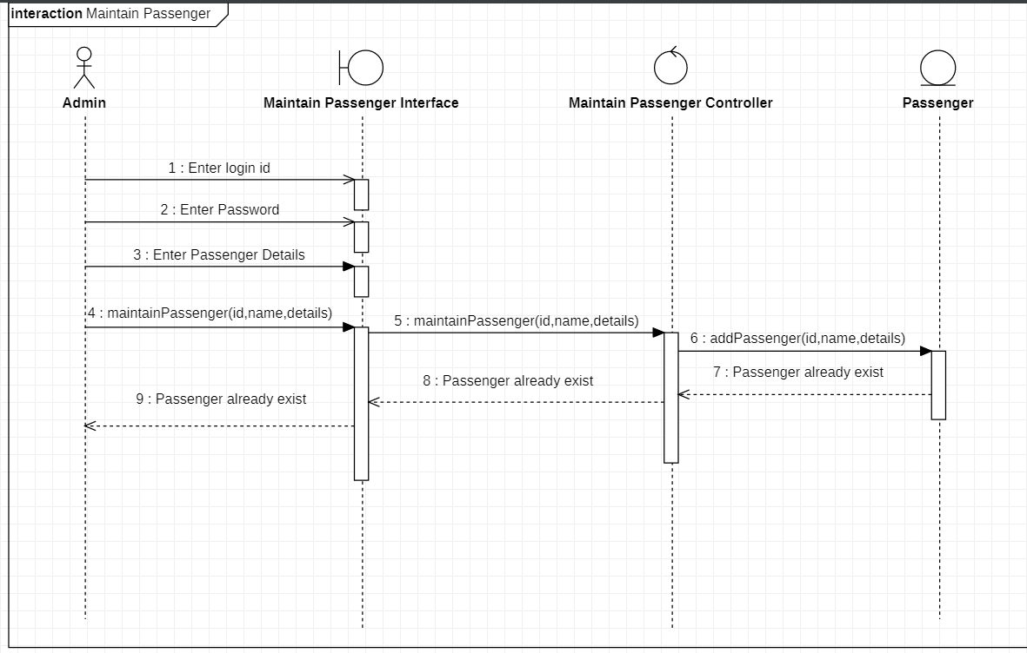

9.6 Passenger Not Found- if in the delete subflow passenger is not found

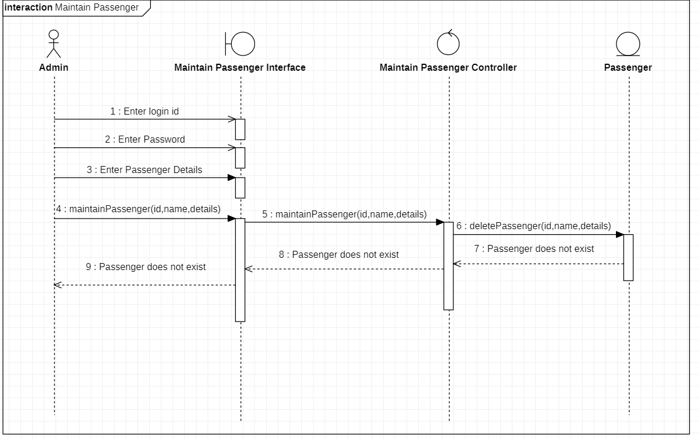

9.7 Update Cancelled

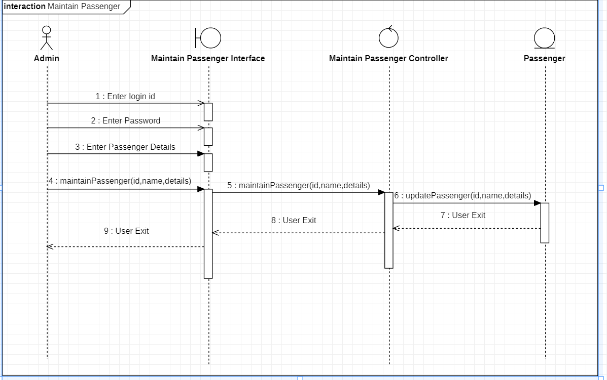

10. **MAINTAIN STAFF DETAILS**

BASIC FLOW

10.1 Add Staff

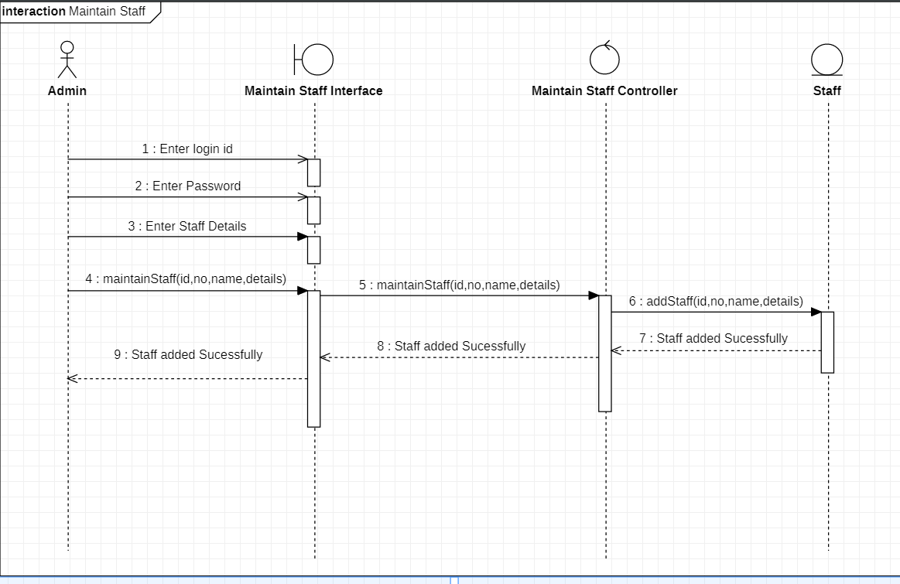

10.2 Update Staff

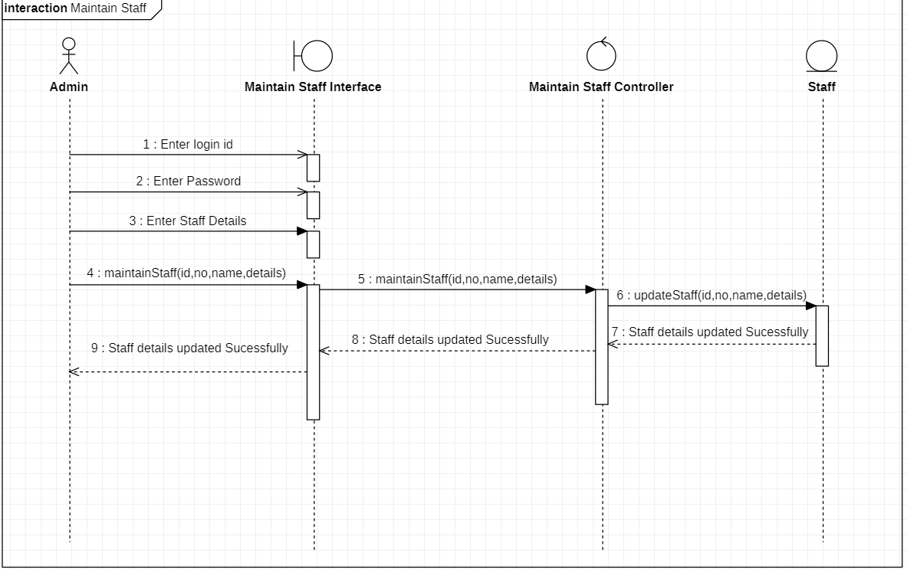

10.3 Delete Staff

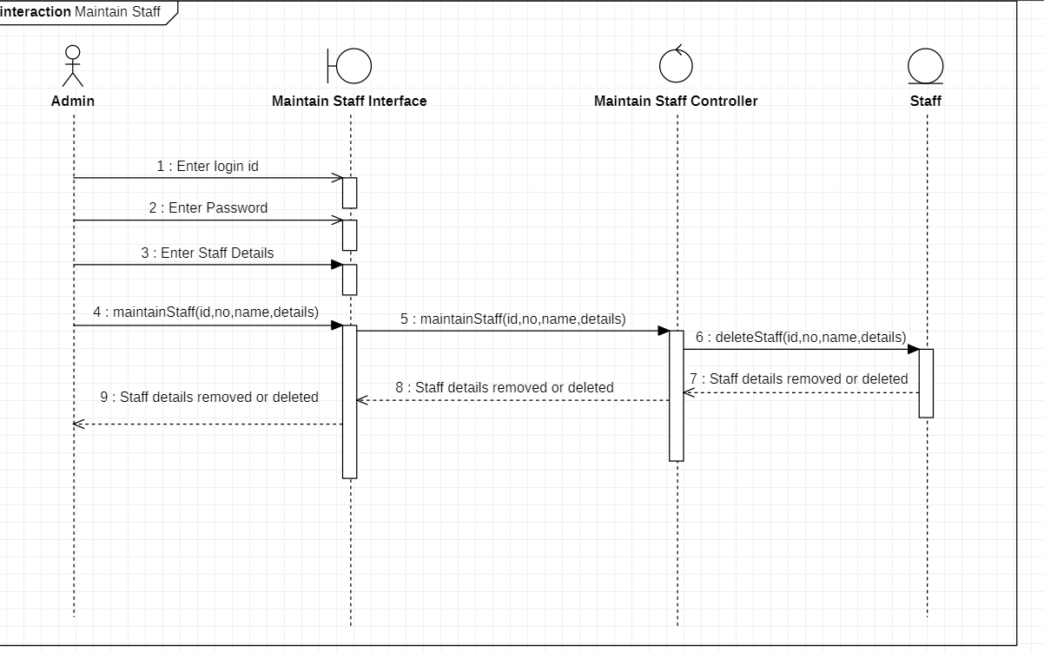

ALTERNATE FLOW

10.4 Invalid Details

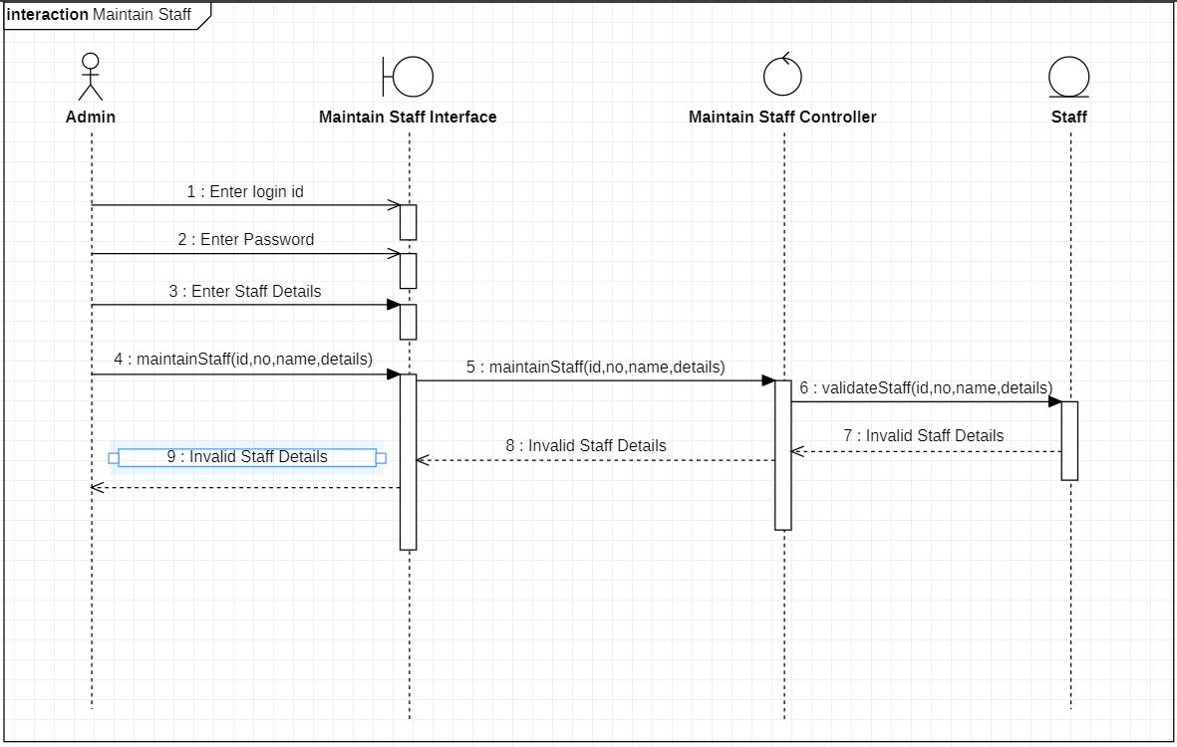

10.5 Staff Already Exist - in the add staff if the staff already exist

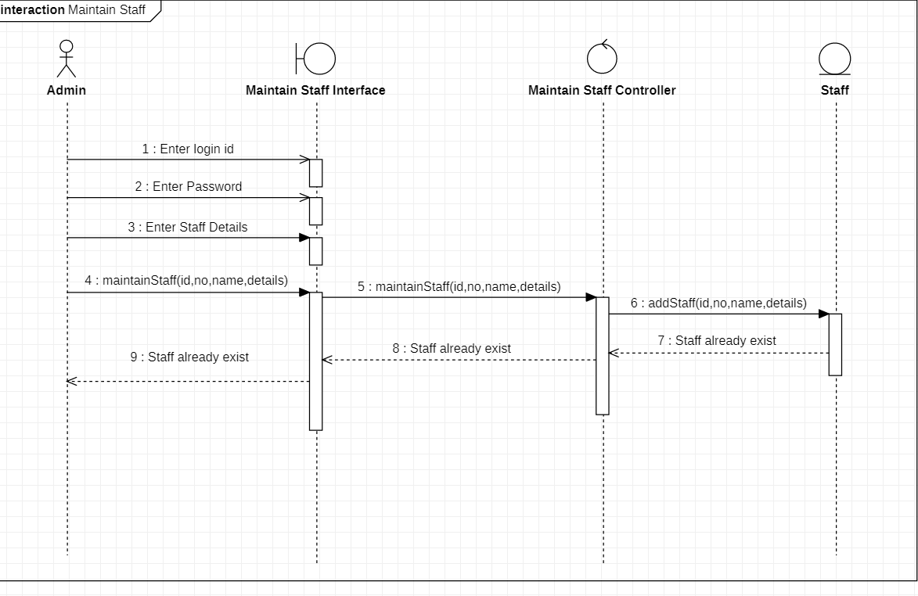

10.6 Staff Not found - in delete staff if the staff not found

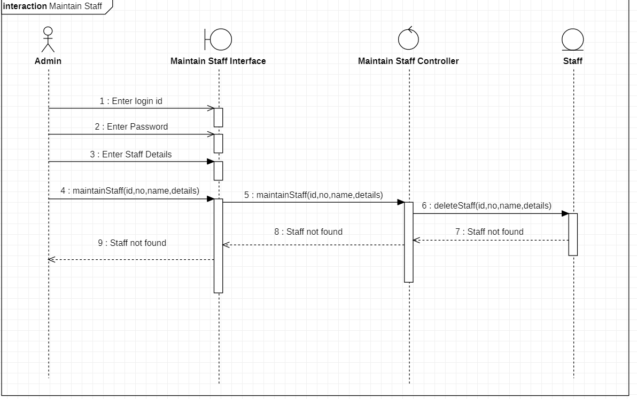

10.7 Update Cancelled

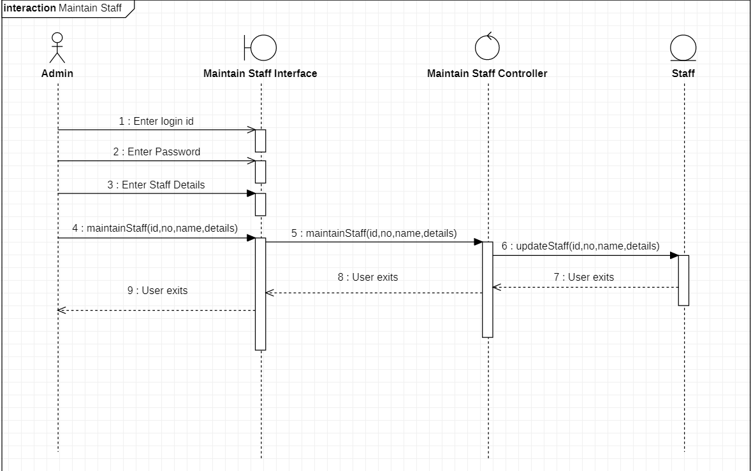

11 **MAINTAIN FLIGHT DETAILS**

Basic Flow

11.1 Add a Flight

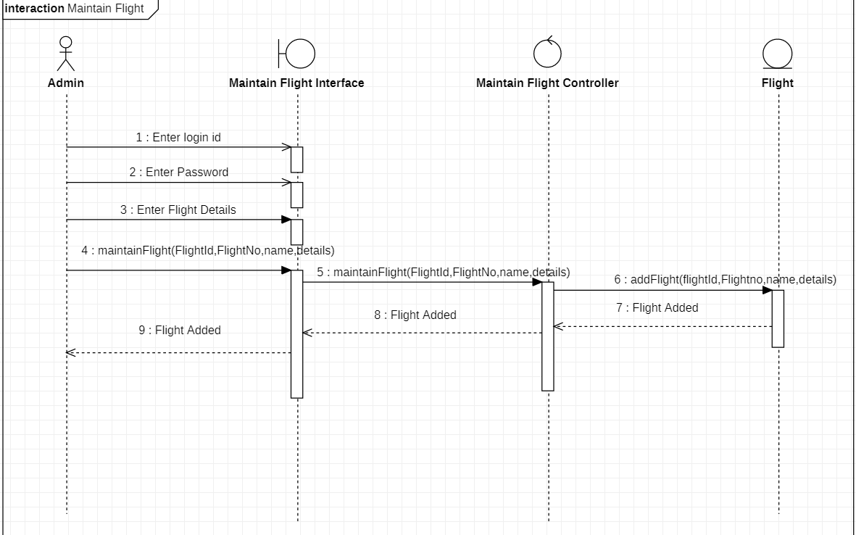

11.2 Update a Flight

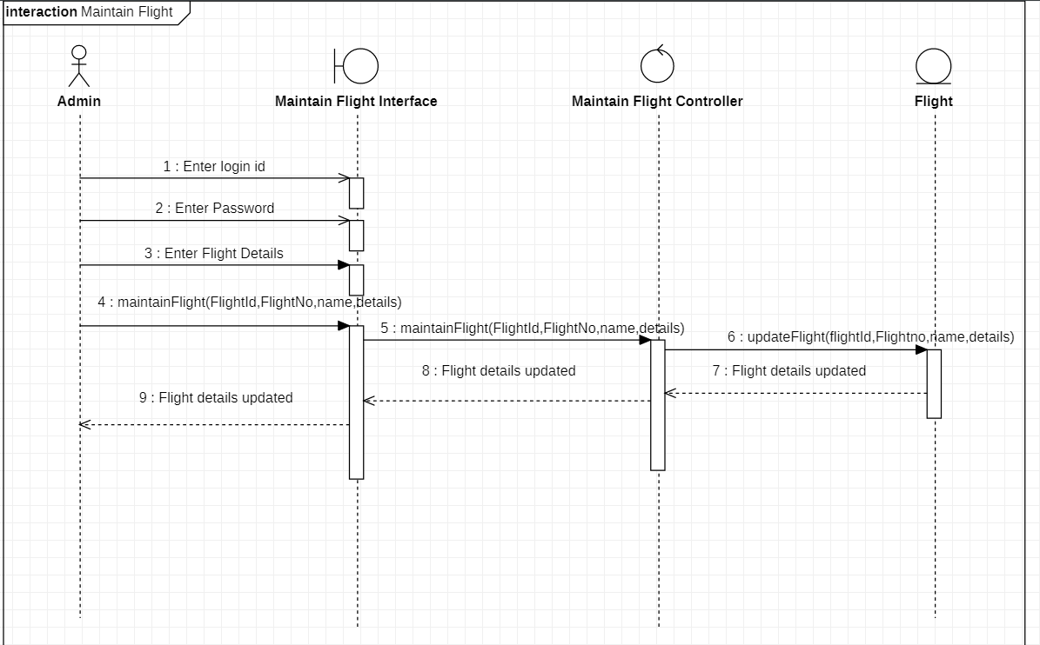

11.3 Delete Flight Details

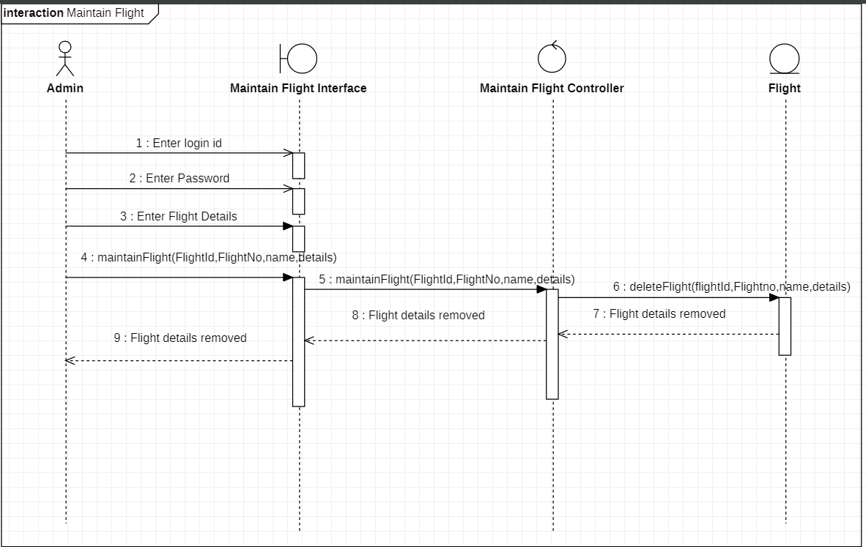

Alternate Flow

11.4 Invalid Flight Details

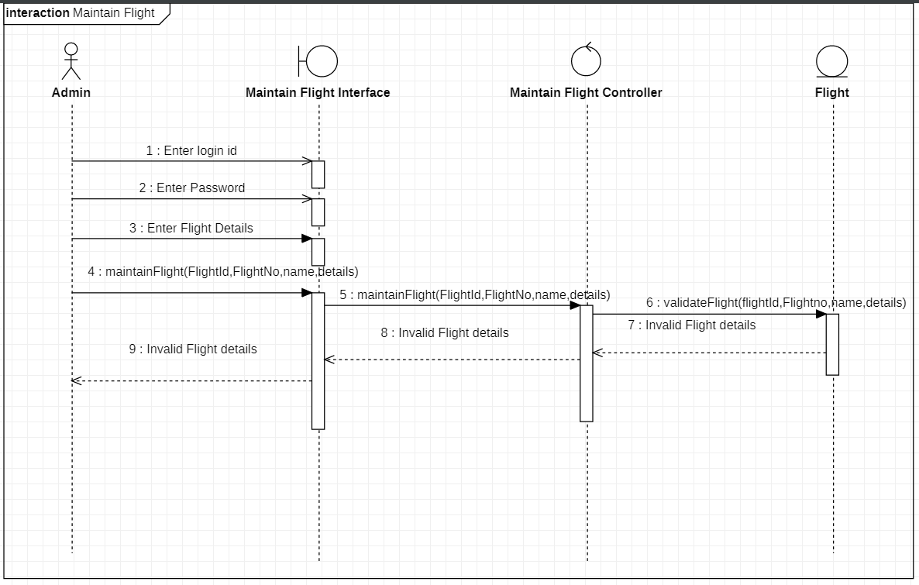

11.5 Flight Already Exist

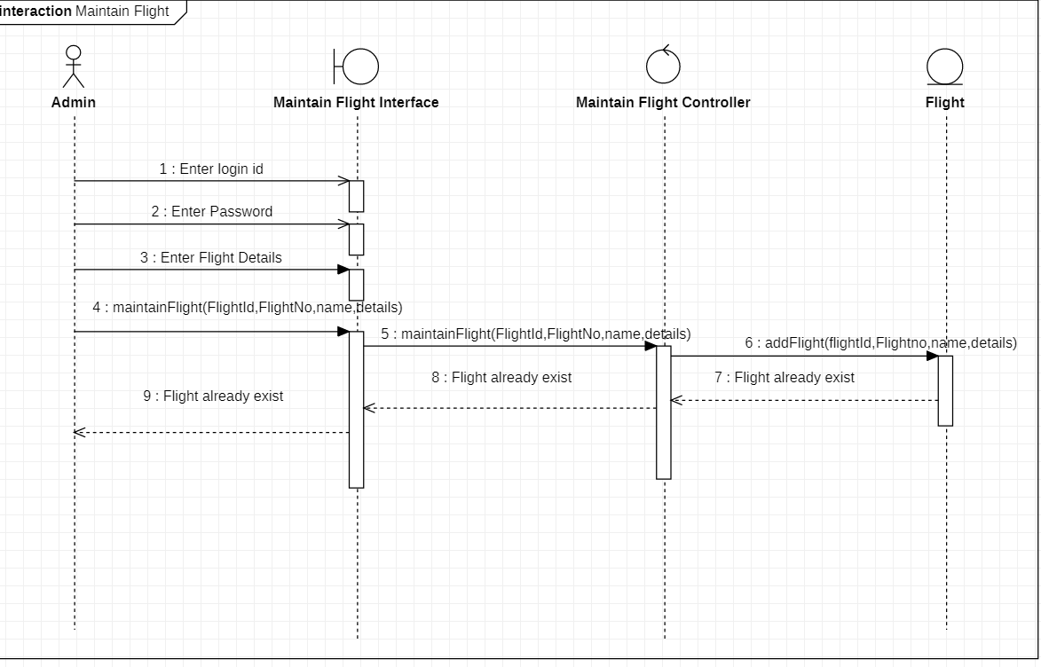

11.6 Update Cancelled

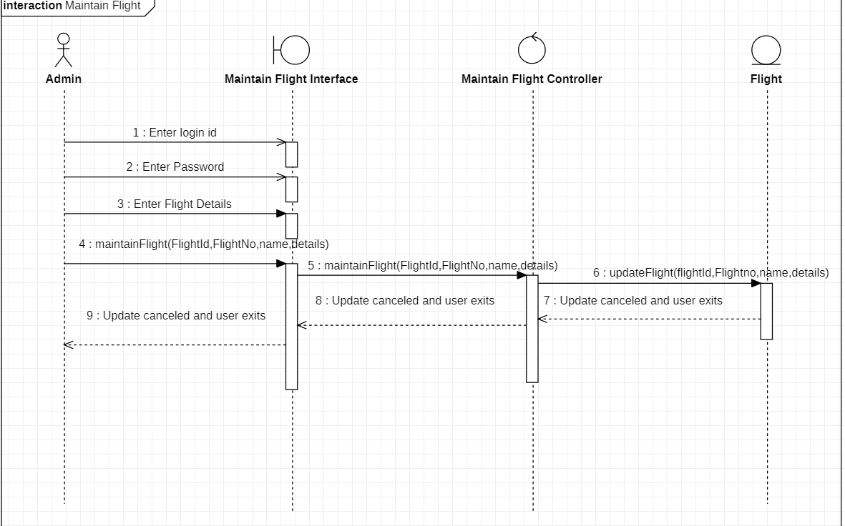

11.7 Flight Not Found

